|  |
| --- |
|  |
| Capstone Project Document |

**Vietnamese Medicinal Plants Network**

Report #6 – User Guide

|  |  |  |
| --- | --- | --- |
| **Vietnamese Medicinal Plants Network** | | |
| **Group Members** | Nguyễn Minh Tiến | SE02545 |
| Trần Bình Khánh | SE02764 |
| Nguyễn Hải Đăng | SE02992 |
| Hoàng Thị Quỳnh | SE02639 |
| **Supervisor** | Mr. Nguyễn Văn Sang | |
| **Project code** | VMN | |

**- Hanoi, 04/2016 -**

# SIGNATURE PAGE

AUTHOR: Nguyễn Hải Đăng 15/04/2016

Team member

REVIEWERS: Nguyễn Minh Tiến 16/04/2016

Project manager

APPROVAL: Nguyễn Văn Sang --/--/--16

Supervisor

Record of change

*A - Added M - Modified D – Deleted

|  |  |  |  |  |  |
| --- | --- | --- | --- | --- | --- |
| Effective Date | Changed Item | A,M,D | Change Description | Reason for Change | Rev. Number |
| 15/April/2016 | User guide | A | Add new |  | 1.0 |
|  |  |  |  |  |  |
|  |  |  |  |  |  |
|  |  |  |  |  |  |
|  |  |  |  |  |  |
|  |  |  |  |  |  |
|  |  |  |  |  |  |
|  |  |  |  |  |  |
|  |  |  |  |  |  |
|  |  |  |  |  |  |
|  |  |  |  |  |  |
|  |  |  |  |  |  |
|  |  |  |  |  |  |
|  |  |  |  |  |  |
|  |  |  |  |  |  |
|  |  |  |  |  |  |

Table of Contents

SIGNATURE PAGE 1

1 Introduction 3

2 USER GUIDELINES 3

2.1 Register 3

2.2 Login 4

2.3 Search 5

2.4 Medicinal Plants 7

2.5 Remedy 7

2.6 Herbal medicine store 8

2.7 Contribute new article 9

2.8 Edit article 10

2.9 Article detail 12

2.10 Report 13

2.11 Menu account 14

2.12 Admin 16

2.13 Mod 19

# Introduction

This user's manual has been developed to help users better understand the requirements that may apply to use this website by providing them simple step by step tutorials. This manual is intended to help make website's functions more accessible and their associated requirements more understandable to users.

# USER GUIDELINES

## Register

To register account on website, the users do the steps below:

Step 1: Open browser and enter to the address bar: <http://vmn.vnvalley.com>. Homepage is displayed.

Step 2: Click on Đăng ký button in header. Users will go to register page.

Step 3: Enter information and click on Đăng ký button or Đăng ký nhà thuốc link.

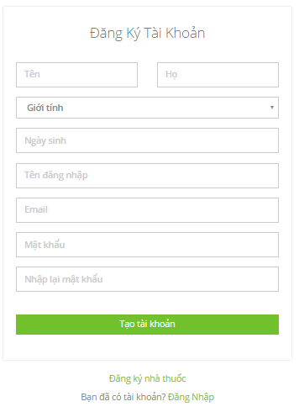

1. R**egister normal account screen**

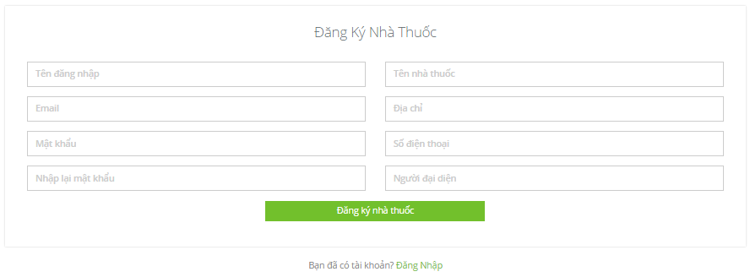

1. R**egister herbal medicine store account screen**

## Login

To login account on website, the users do the steps below:

Step 1: Open browser and enter to the address bar: <http://vmn.vnvalley.com> . Homepage is displayed.

Step 2: Click on Đăng nhập button in header. User will go to Login page.

Step 3: User login to VMN system:

Step 3.1: User enter username and password

Step 3.2: Click on “Đăng nhập” button

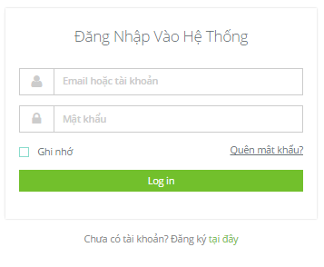

1. Login **page**

## Search

### Basic Search

To use search function on website, the users do the steps below:

Step 1: Open browser and enter to the address bar: <http://vmn.vnvalley.com> .

Step 2: In Home page, click on “Cây thuốc” or “Bài thuốc” button in header.

Step 3: Input keywords and click on search icon or press enter.

Macintosh HD:Users:nguyenhaidang:Desktop:Screen Shot 2016-04-15 at 14.52.08.png

1. Basic search screen

Step3: Search result page is displayed.

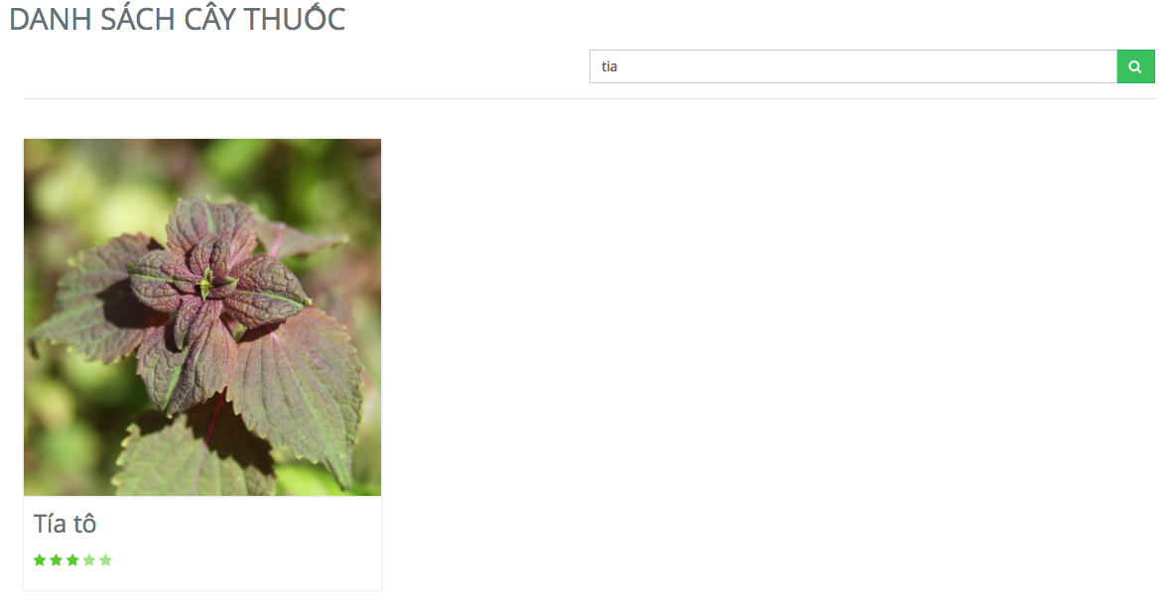

1. Search screen result

### Advance search medicinal plant

To use advance search medicinal plant function on website, the users do the steps below:

Step 1: Open browser and enter to the address bar: <http://vmn.vnvalley.com> .

Step 2: In Home page, click on “Cây thuốc” button in header.

Step 3: Click on “Hiển thị tìm kiếm nâng cao” button.

Step 4: Input keywords and click on “Tìm kiếm” button.

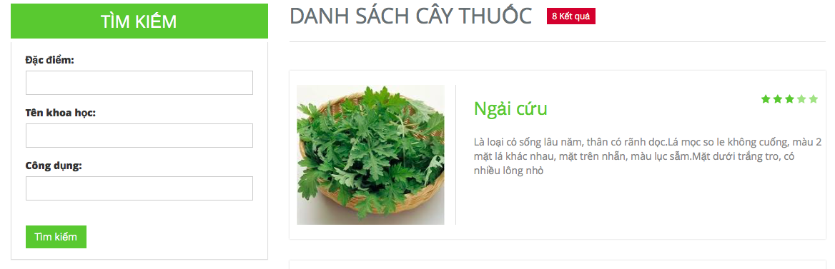

1. Advance search medicinal plant

### Advance search remedy

To use advance search remedy function on website, the users do the steps below:

Step 1: Open browser and enter to the address bar: <http://vmn.vnvalley.com> .

Step 2: In Home page, click on “Bài thuốc” button in header.

Step 3: Click on “Hiển thị tìm kiếm nâng cao” button.

Step 3: Input keywords and click on “Tìm kiếm” button.

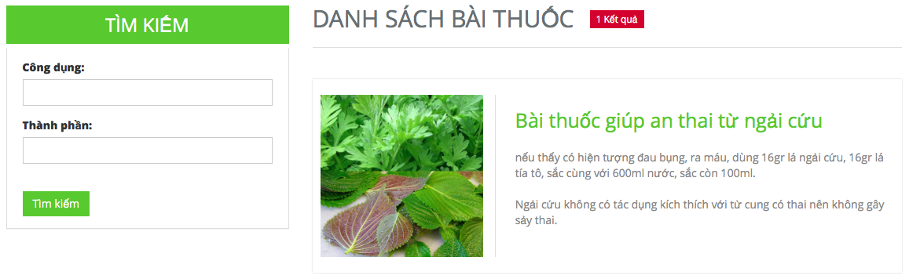

1. Advance search remedy

## Medicinal Plants

Click button Medicinal Plants in header to go to medicinal plants page.

To use contribute medicinal plants article or advance search medicinal plants function on website, the users do step below:

Step 1: Open browser and enter to the address bar: <http://vmn.vnvalley.com> .

Step 2: In home page click on button “Cây thuốc” in header.

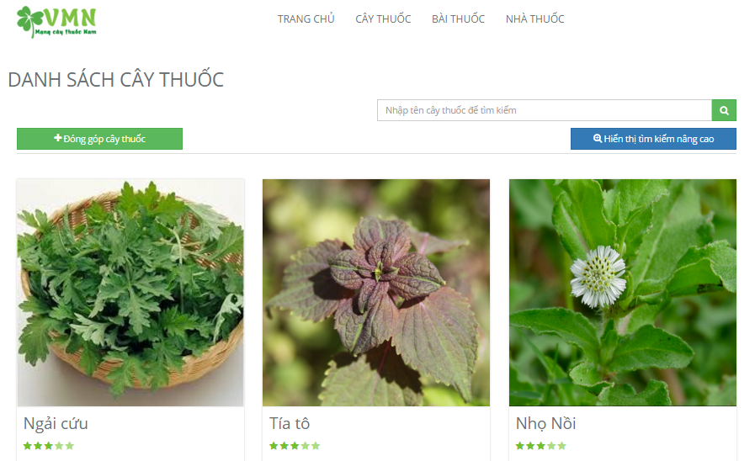

1. Medicinal plants

## Remedy

Click button Medicinal Plants in header to go to remedy page

To use contribute remedy article or advance search remedy function on website, the users do step below:

Step 1: Open browser and enter to the address bar: <http://vmn.vnvalley.com> .

Step 2: In home page click on button “Bài thuốc” in header.

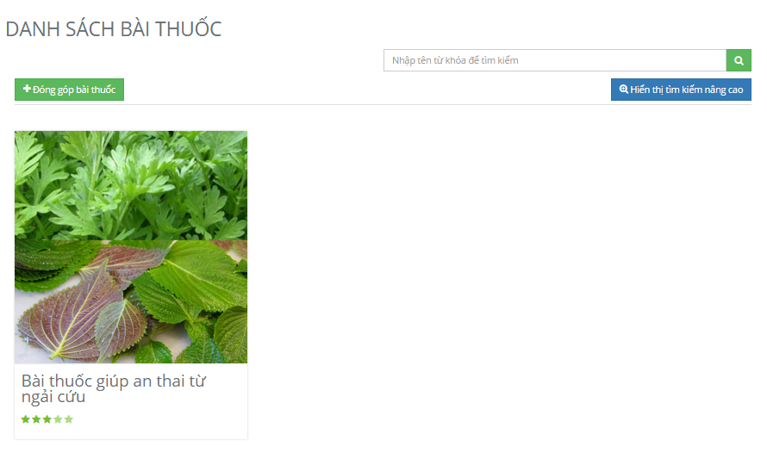

1. Remedy

## Herbal medicine store

To use herbal medicine store search function on the website, the users do the steps below:

Step 1: Open browser and enter to the address bar: <http://vmn.vnvalley.com> .

Step 2: Click on login button in header and login vmn system successful.

Step 3: Click on “Nhà thuốc” button in header.

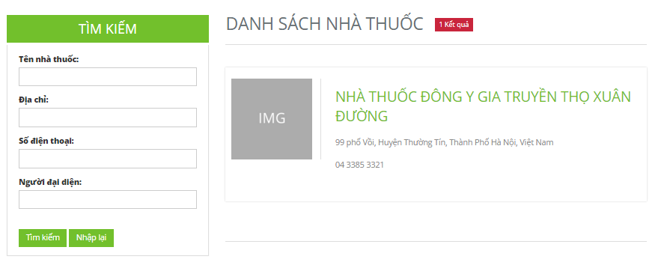

1. Herbal medicine store

### Herbal medicine store detail

Click on a herbal medicine store in herbal medicine store page to go to herbal medicine store detail.

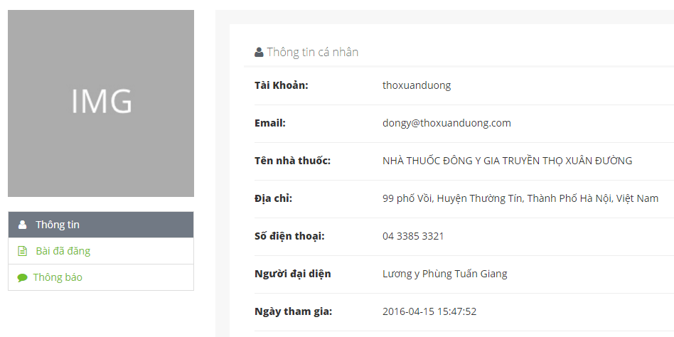

1. Herbal medicine store detail

## Contribute new article

### Contribute new medicinal plant

To use contribute new medicinal plant function on the website, the users do the steps below:

Step 1: Open browser and enter to the address bar: <http://vmn.vnvalley.com> .

Step 2: Click on “Đăng nhập” button in header and login vmn system successful.

Step 3: Click on “Cây thuốc” button in header.

Step 4: Click on “Đóng góp cây thuốc” button.

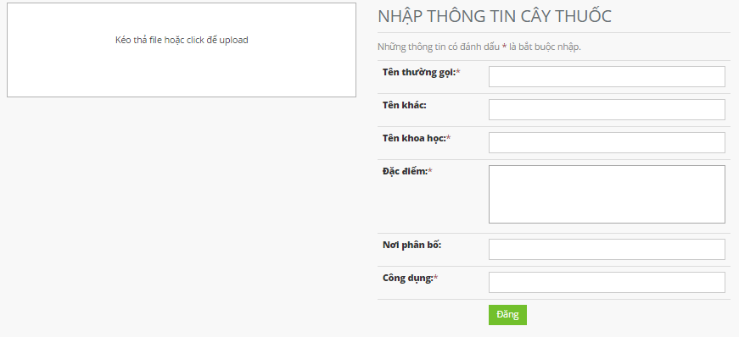

1. Contribute new medicinal plant

### Contribute new remedy

To use contribute new remedy function on the website, the users do the steps below:

Step 1: Open browser and enter to the address bar: <http://vmn.vnvalley.com> .

Step 2: Click on “Đăng nhập” button in header and login vmn system successful.

Step 3: Click on “Bài thuốc” button in header.

Step 4: Click on “Đóng góp bài thuốc” button.

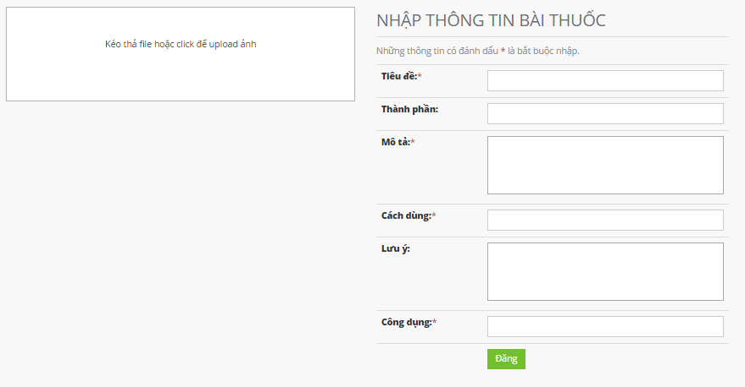

1. Contribute new remedy

## Edit article

### Edit medicinal plants article

To use edit medicinal plants article function on the website, the users do the steps below:

Step 1: Open browser and enter to the address bar: <http://vmn.vnvalley.com> .

Step 2: Click on “Đăng nhập” button in header and login vmn system successful.

Step 3: Click on “Cây thuốc” button in header.

Step 4: Click on a medicinal plant article.

Step 5: Click on “Chỉnh sửa” button. (“Chỉnh sửa” button is displayed only if the user contributed this article).

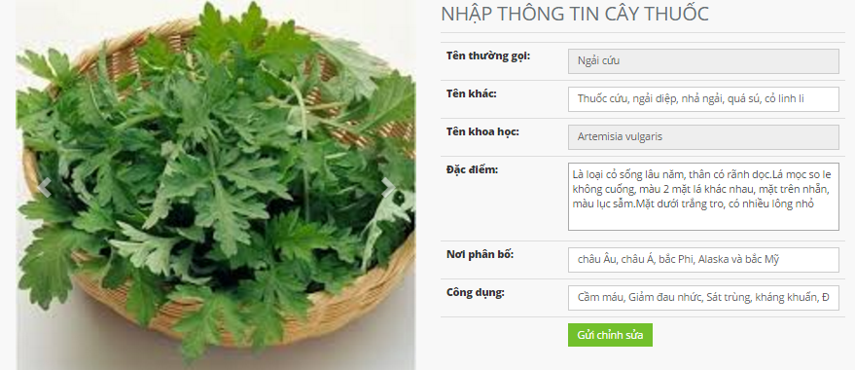

1. Edit medicinal plants article

### Edit remedy article

To use edit remedy article function on the website, the users do the steps below:

Step 1: Open browser and enter to the address bar: <http://vmn.vnvalley.com> .

Step 2: Click on “Đăng nhập” button in header and login vmn system successful.

Step 3: Click on “Bài thuốc” button in header.

Step 4: Click on a remedy article.

Step 5: Click on “Chỉnh sửa” button. (“Chỉnh sửa” button is displayed only if the user contributed this article).

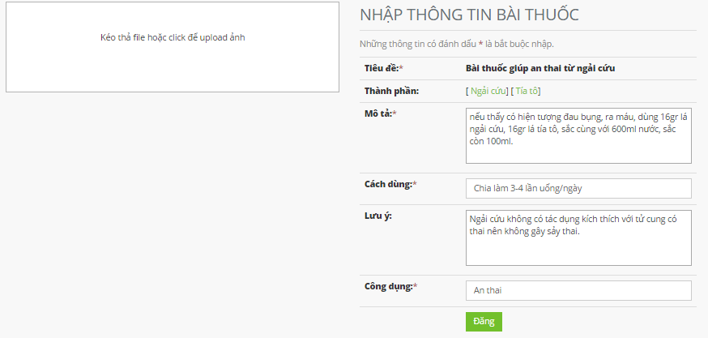

1. Edit remedy article

## Article detail

### Medicinal plant detail

To use medicinal plants detail function on the website, the users do the steps below:

Step 1: Open browser and enter to the address bar: <http://vmn.vnvalley.com> .

Step 2: Click on “Đăng nhập” button in header and login vmn system successful.

Step 3: Click on “Cây thuốc” button in header.

Step 4: Click on a medicinal plant article.

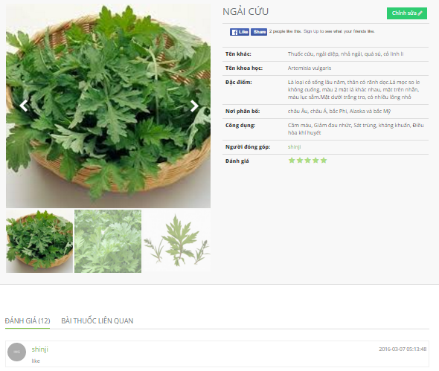

1. Medicinal plant detail

### Remedy detail

To use remedy detail function on the website, the users do the steps below:

Step 1: Open browser and enter to the address bar: <http://vmn.vnvalley.com> .

Step 2: Click on “Đăng nhập” button in header and login vmn system successful.

Step 3: Click on “Bài thuốc” button in header.

Step 4: Click on a remedy article.

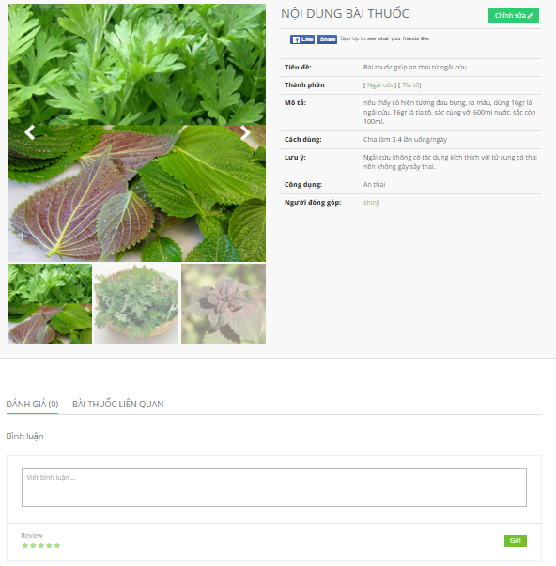

1. Remedy detail

## Report

To use report function on the website, the users do the steps below:

Step 1: Open browser and enter to the address bar: <http://vmn.vnvalley.com> .

Step 2: Click on “Đăng nhập” button in header and login vmn system successful.

Step 3: Click on “Cây thuốc” or “Bài thuốc” button in header.

Step 4: Click on a medicinal plant or a remedy article.

Step 5: Click on “Báo cáo” button (“Báo cáo” button is displayed only if this article is not the user’s article).

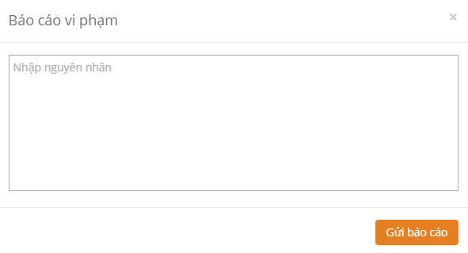

1. Report

## Menu account

### User profile

To use view user profile function, the users can do one of 2 ways below:

Way 1: User do not login vmn system.

Step 1: Open browser and enter to the address bar: <http://vmn.vnvalley.com> .

Step 2: Click on “Cây thuốc” or “Bài thuốc” button in header.

Step 3: Click on a medicinal plant or a remedy article.

Step 4: Click on an author link of this article.

Way 2: User login vmn system successful.

Step 1: Open browser and enter to the address bar: <http://vmn.vnvalley.com> .

Step 2: Click on user profile link in header.

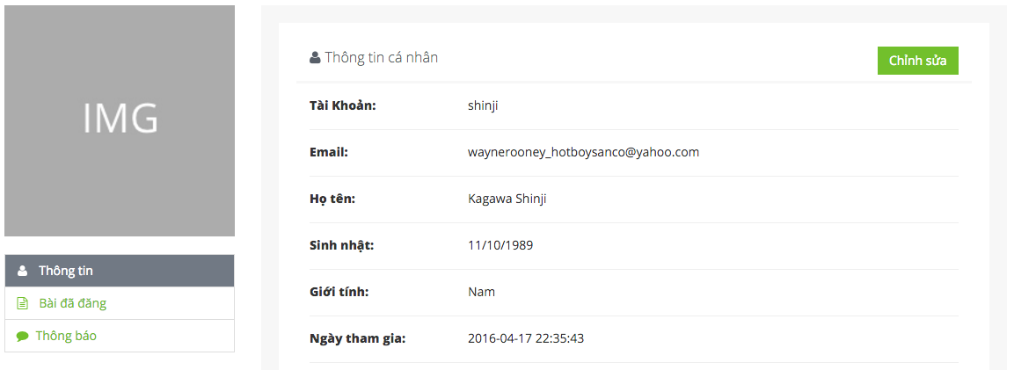

1. User profile

### Change profile

To use change profile function, the users do the steps below:

Step 1: Open browser and enter to the address bar: <http://vmn.vnvalley.com> .

Step 2: Click on user profile link in header.

Step 3: Click on “Chỉnh sửa” button on user profile page.

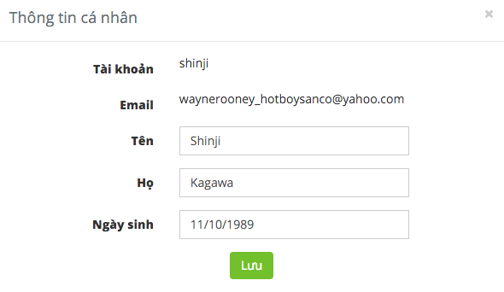

1. Change profile

### Message content

To use message content function, the users do the steps below:

Step 1: Open browser and enter to the address bar: <http://vmn.vnvalley.com> .

Step 2: Click on user profile link in header.

Step 3: Click on “Thông báo” button.



1. Message content

### Contributed articles

To use contributed articles function, the users do the steps below:

Step 1: Open browser and enter to the address bar: <http://vmn.vnvalley.com> .

Step 2: Click on user profile link in header.

Step 3: Click on “Bài đã đăng” button.

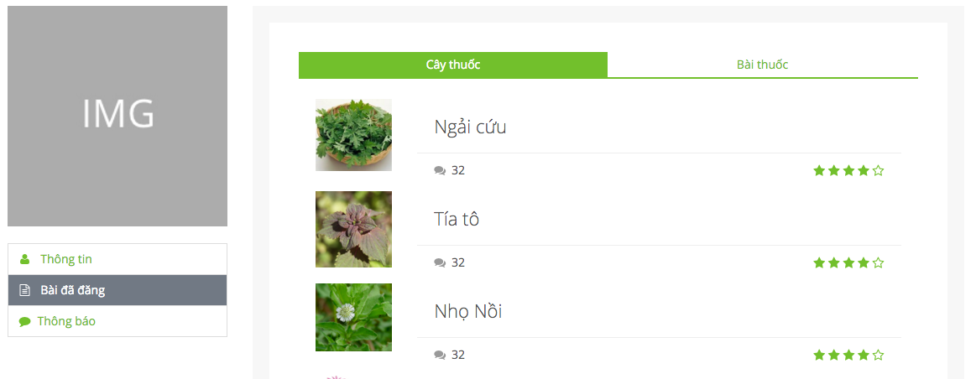

1. Contributed articles

## Admin

### Dashboard of admin

To view dashboard of admin, the users do the steps below:

Step 1: Open browser and enter to the address bar: <http://admin.vmn.vnvalley.com/managementLogin> .

Step 2: Write username is “iamadmin” and password “tiennm”.

Step 3: Click login button.

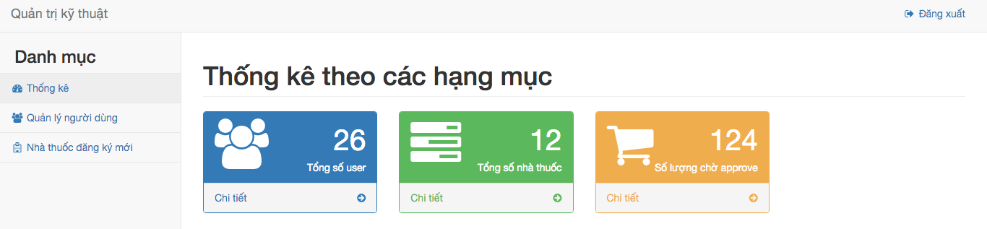

1. Dashboard of admin

### Member management

To use member management function, the users do the steps below:

Step 1: Open browser and enter to the address bar: <http://admin.vmn.vnvalley.com/managementLogin> .

Step 2: Login successful.

Step 3: Click on “Quản lý người dùng” button.

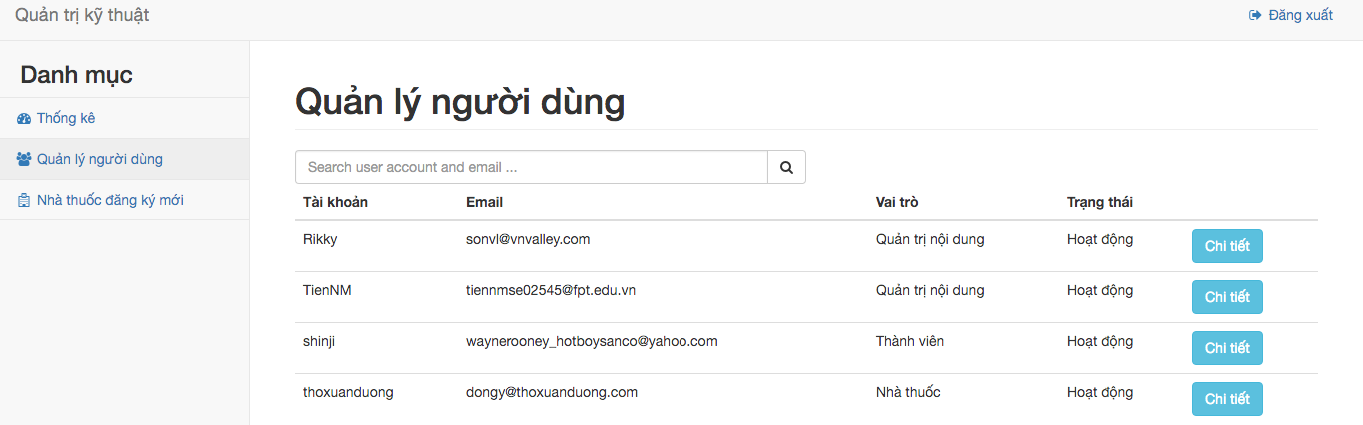

1. Member management

### Member detail

To use member management function, the users do the steps below:

Step 1: Open browser and enter to the address bar: <http://admin.vmn.vnvalley.com/managementLogin> .

Step 2: Login successful.

Step 3: Click on “Quản lý người dùng” button.

Step 4: Click on “Chi tiết” button of an account.

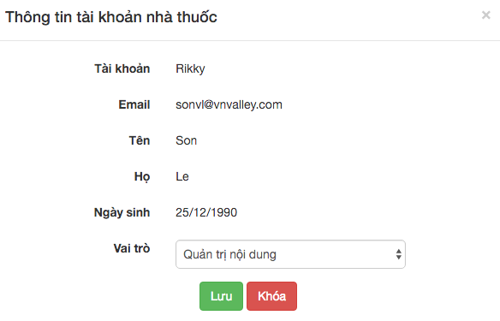

1. Member detail

### Herbal medicine store management

To use member management function, the users do the steps below:

Step 1: Open browser and enter to the address bar: <http://admin.vmn.vnvalley.com/managementLogin> .

Step 2: Login successful.

Step 3: Click on “Nhà thuốc đăng ký mới” button.

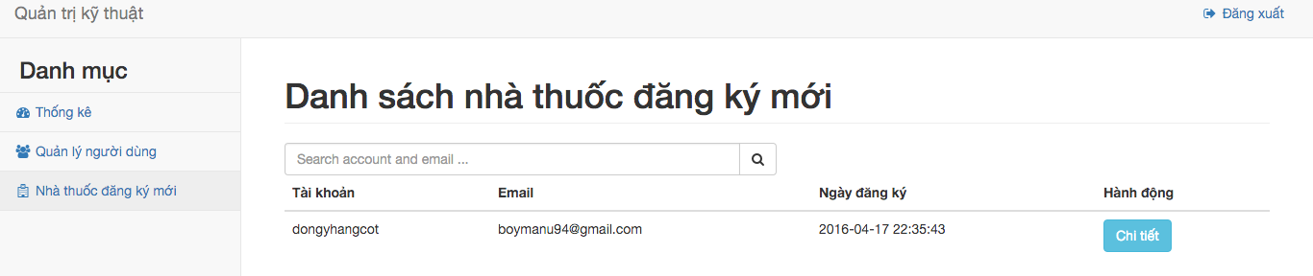

1. Herbal medicine store management

### Herbal medicine store detail

To use member management function, the users do the steps below:

Step 1: Open browser and enter to the address bar: <http://admin.vmn.vnvalley.com/managementLogin> .

Step 2: Login successful.

Step 3: Click on “Nhà thuốc đăng ký mới” button.

Step 4: Click on “Chi tiết” button of an account.

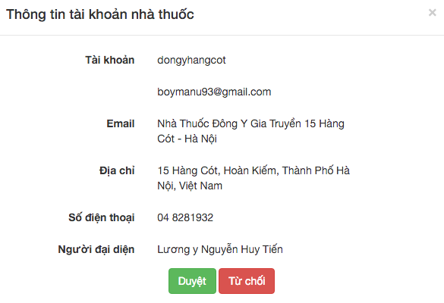

1. Herbal medicine store detail

## Mod

### Dashboard of mod

To view dashboard of admin, the users do the steps below:

Step 1: Open browser and enter to the address bar: <http://admin.vmn.vnvalley.com/managementLogin> .

Step 2: Write username is “tiennm” and password “tiennm”.

Step 3: Click login button.

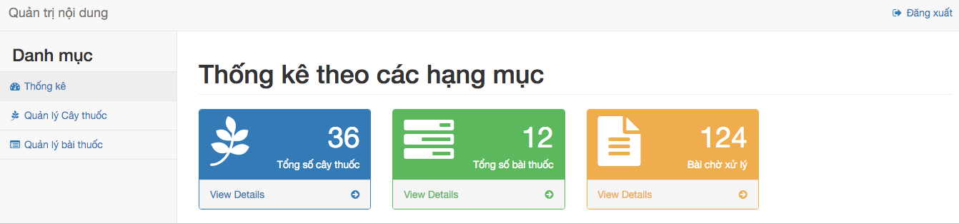

1. Dashboard of mod

### New medicinal plants management

To use member management function, the users do the steps below:

Step 1: Open browser and enter to the address bar: <http://admin.vmn.vnvalley.com/managementLogin> .

Step 2: Login successful.

Step 3: Click on “Quản lý cây thuốc” button.

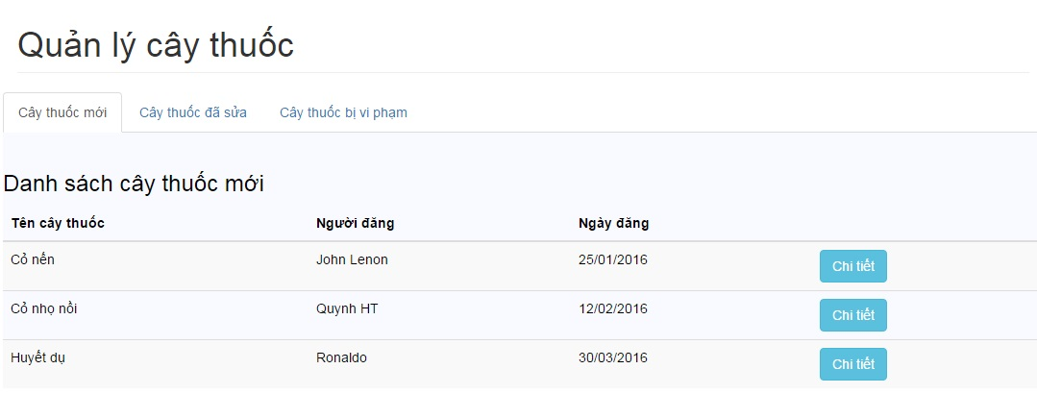

1. New medicinal plants management

### New medicinal plant detail

To use member management function, the users do the steps below:

Step 1: Open browser and enter to the address bar: <http://admin.vmn.vnvalley.com/managementLogin> .

Step 2: Login successful.

Step 3: Click on “Quản lý cây thuốc” button.

Step 4: Click on “Chi tiết” button.

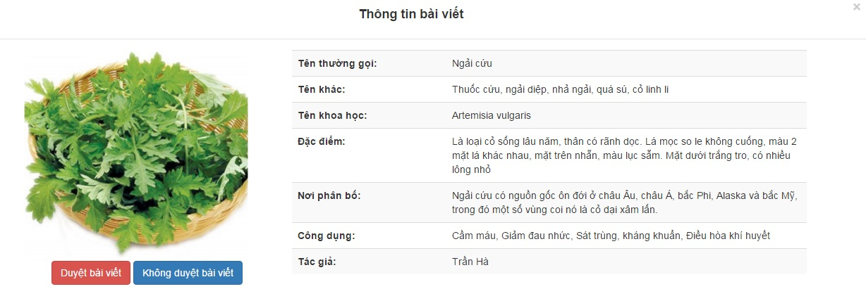

1. New medicinal plant detail

### Edited medicinal plants management

To use member management function, the users do the steps below:

Step 1: Open browser and enter to the address bar: <http://admin.vmn.vnvalley.com/managementLogin> .

Step 2: Login successful.

Step 3: Click on “Quản lý cây thuốc” button.

Step 4: Click on “Cây thuốc đã sửa” button.

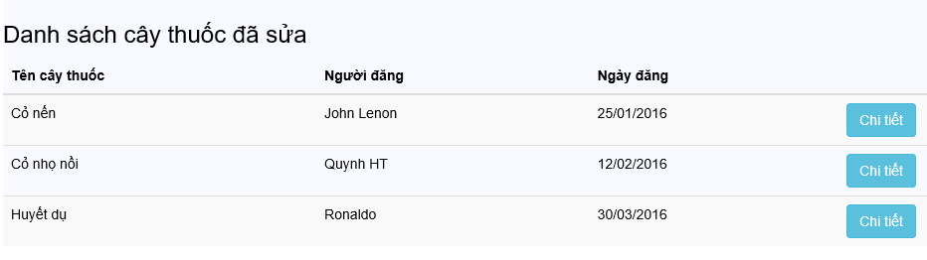

1. Edited medicinal plants management

### Edited medicinal plant detail

To use member management function, the users do the steps below:

Step 1: Open browser and enter to the address bar: <http://admin.vmn.vnvalley.com/managementLogin> .

Step 2: Login successful.

Step 3: Click on “Quản lý cây thuốc” button.

Step 4: Click on “Cây thuốc đã sửa” button.   
Step 5: Click on “Chỉnh sửa” button.



1. Edited medicinal plant detail

### Reported medicinal plants management

To use member management function, the users do the steps below:

Step 1: Open browser and enter to the address bar: <http://admin.vmn.vnvalley.com/managementLogin> .

Step 2: Login successful.

Step 3: Click on “Quản lý cây thuốc” button.

Step 4: Click on “Báo cáo cây thuốc” button.

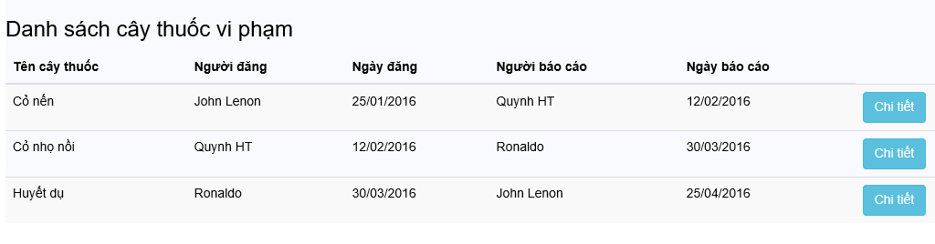

1. Reported medicinal plants management

### Reported medicinal plant detail

To use member management function, the users do the steps below:

Step 1: Open browser and enter to the address bar: <http://admin.vmn.vnvalley.com/managementLogin> .

Step 2: Login successful.

Step 3: Click on “Quản lý cây thuốc” button.

Step 4: Click on “Báo cáo cây thuốc” button.

Step 5: Click on “Chi tiết” button.

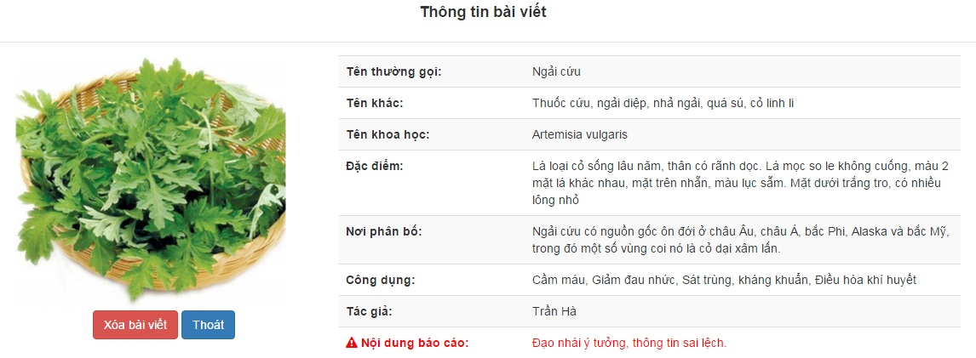

1. Reported medicinal plant detail

### New remedy management

To use member management function, the users do the steps below:

Step 1: Open browser and enter to the address bar: <http://admin.vmn.vnvalley.com/managementLogin> .

Step 2: Login successful.

Step 3: Click on “Quản lý bài thuốc” button.

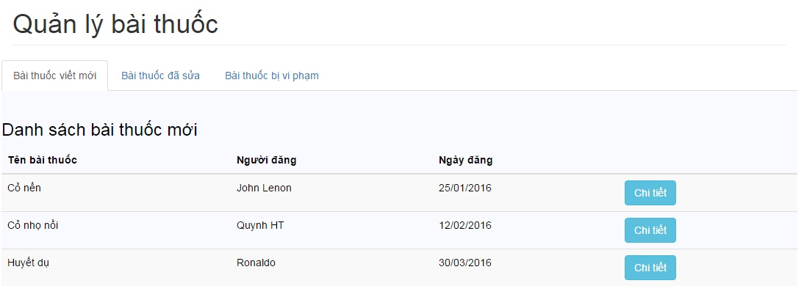

1. New remedy management

### New remedy detail

To use member management function, the users do the steps below:

Step 1: Open browser and enter to the address bar: <http://admin.vmn.vnvalley.com/managementLogin> .

Step 2: Login successful.

Step 3: Click on “Quản lý bài thuốc” button.

Step 4: Click on “Chi tiết” button.

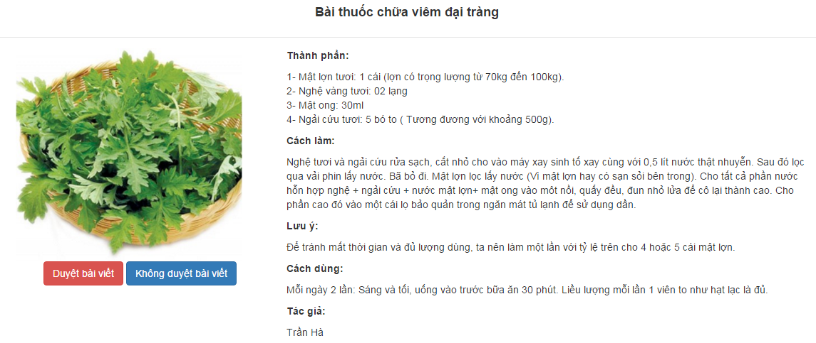

1. New remedy detail

### Edited remedy management

To use member management function, the users do the steps below:

Step 1: Open browser and enter to the address bar: <http://admin.vmn.vnvalley.com/managementLogin> .

Step 2: Login successful.

Step 3: Click on “Quản lý bài thuốc” button.

Step 4: Click on “Yêu cầu chỉnh sửa bài thuốc” button.

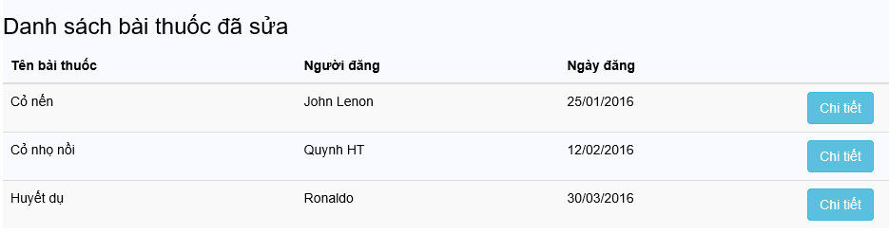

1. Edited remedy management

### Edited remedy detail

To use member management function, the users do the steps below:

Step 1: Open browser and enter to the address bar: <http://admin.vmn.vnvalley.com/managementLogin> .

Step 2: Login successful.

Step 3: Click on “Quản lý bài thuốc” button.

Step 4: Click on “Yêu cầu chỉnh sửa bài thuốc” button.

Step 5: Click on “Chi tiết” button.



1. Edited remedy detail

### Reported remedy management

To use member management function, the users do the steps below:

Step 1: Open browser and enter to the address bar: <http://admin.vmn.vnvalley.com/managementLogin> .

Step 2: Login successful.

Step 3: Click on “Quản lý bài thuốc” button.

Step 4: Click on “Danh sách báo cáo” button.



1. Reported remedy management

### Reported remedy detail

To use member management function, the users do the steps below:

Step 1: Open browser and enter to the address bar: <http://admin.vmn.vnvalley.com/managementLogin> .

Step 2: Login successful.

Step 3: Click on “Quản lý bài thuốc” button.

Step 4: Click on “Danh sách báo cáo” button.

Step 5: Click on “Chi tiết” button.

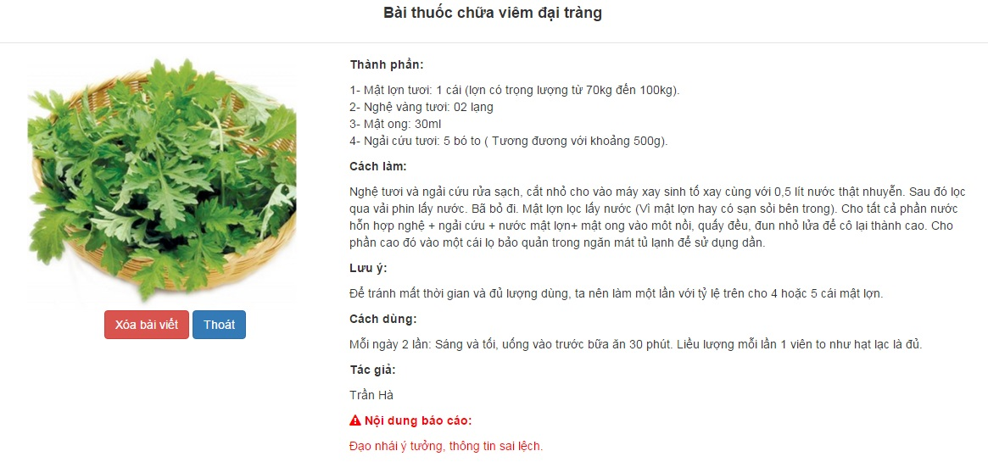

1. Reported remedy detail